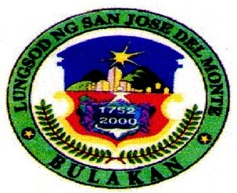

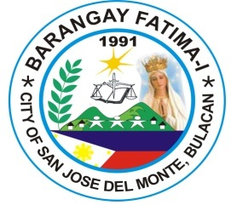

**REPUBLIC OF THE PHILIPPINES**

**PROVINCE OF BULACAN**

**CITY OF San Jose Del Monte**

**office of the PUNONG Barangay**

***#301 St. Jude St. Fatima I, City of San Jose del Monte, Bulacan, 3024***

2

Control No.: 221

TO WHOM IT MAY CONCERN:

This is to Certify that **­**_____________________________, ____ years old, is a bonafide resident of __________________________ Street, Barangay Fatima-I, City of San Jose Del Monte, Bulacan since ______ up to present.

This CERTIFICATION is being issued upon the request of ___________________________ for whatever legal intent and purposes particularly for:

_________________________

Issued this ____ day of ______________, _____ at the Office of the Punong Barangay, Barangay Fatima-I, City of San Jose Del Monte, Bulacan.

**HON. GEORGE S. TABLAN, JR.**

Punong Barangay

*ATTESTED BY:*

Not valid w/o Dry Seal

Date: _____________

**CHARMAINE R. FADRIQUELA**

Barangay Secretary

Applicant:

____________________________

Signature Over-Printed Name

Res. Cert. No. ________________

Issued on: ___________________

Issued at: ___________________

NOTE: This CERTIFICATION is valid only for six (6) months period from the date issued.

**HON. GEORGE S. TABLAN, JR.**

Punong Barangay

Mga Kasangguni sa Sangguniang Barangay

**HON. LUZVIMINDA T. PAGCANLUNGAN**

**Chairman Committee on Ethics and Privileges /**

**Transportation and Communication**

**HON. REDEL T. DELFIN**

**Chairman Committee on Livelihood, Trade and Industry / Public Works / Patrimonial Property**

**HON. CRISTINA C. BALMORES**

**Chairman, Committee on Health / Land Use and Zoning**

**HON. AMBROCIO F. MILO, JR.**

**Chairman Committee on Education / Finance and Appropriation**

**HON. HENRY P. FIEL**

**Chairman Committee Woman and Family Relations / Tourism and Culture**

**HON. MYRNA D. PAILAGA**

**Chairman Committee on Sanitation, Beautification, Agriculture Environment & Natural Resources / Labor and Employment**

**HON. JAY MARK V. ESPAÑOLA**

**Chairman Committee on Peace & Order / Ways and Means / Bids and Awards (BAC)**

**HON. KENNETH T. SOLOMON**

**Chairman Committee on Youth & Sports Development / Human Rights**

**MRS. CHARMAINE R. FADRIQUELA**

**Barangay Secretary**

**MRS. VILMA S. CASTRO**

**Barangay Treasurer**

**MR. REYNALDO V. OCAMPO**

**Barangay Record Keeper (BRK)**

**MR. NOEL L. BIGOL**

**Barangay Administrator Officer**

**MS. HELEN A. SEELIN**

**Barangay Chief-Tanod**

**Right Thumb**